Energy Advice Drop in Sessions
Autumn/Winter 2017/18

We have organised a number of Energy Advice drop in sessions at libraries across the Wyre Forest District throughout the Autumn and Winter period 2017/18. Please drop in and see us to find out how we can help you.

* Save Money on your Fuel Bills & Switch Energy Provider (bring your bills with you) * General Energy Advice
*Find out about Grants for Heating and Insulation * Advice about Smart Meters * Tips on Heating your Home

Date Time Venue What

Tuesday 12th 9.30am – 12.30pm Kidderminster Library, Energy Advice Drop
September 2017 Market Street in session

1.30pm – 4.30pm Stourport Library, Energy Advice drop
Civic Centre, New Street in Session

Tuesday 10th 9.30am – 12.30pm Kidderminster Library, Energy Advice drop
October Market Street in session

1.30pm – 4.30pm Stourport Library, Energy Advice drop
Civic Centre, New Street in session

Tuesday 14th 9.30am – 1.30pm Kidderminster Library, Energy Advice drop
November Market Street in session

1.30pm – 4.30pm Stourport Library, Energy Advice drop
Civic Centre, New Street in Session

Thursday 23rd 9.30am – 1.00pm Bewdley Library, Energy Advice drop
November 2017 Dog Lane in Session

Tuesday 12th 9.30am – 12.30pm Kidderminster Library, Energy Advice drop
December Market Street in session

1.30pm – 4.30pm Stourport Library, Energy Advice drop
Civic Centre, New Street in session

Tuesday 9th 9.30am – 12.30pm Kidderminster Library, Energy Advice drop
January 2018 Market Street in session

1.30pm – 4.30pm Stourport Library, Energy Advice drop
Civic Centre, New Street in session

Thursday 25th 9.30am – 1.00pm Bewdley Library, Energy Advice drop
January 2018 Dog Lane in Session

Come & join AGE UK, Severn Trent, Lifeline, Care & Repair, HWFRS for our ‘Winter Warmth’ partners event at Kidderminster Library on:

Tuesday 13th 9.30am – 1.30pm Kidderminster Library, Winter Warmth
February Market Street Partners Event

Tuesday 13th 9.30am – 12.30pm Kidderminster Library, Energy Advice drop
March Market Street in session

1.30pm – 4.30pm Stourport Library, Energy Advice drop
Civic Centre, New Street in session

Act on Energy working in partnership with Wyre Forest District Council
Tel: 0800 988 2881 www.actonenergy.org.uk advice@actonenergy.org.uk

You will also find Act on Energy at the following
events across the Wyre Forest Region in 2017/2018

Date Time Venue What

Thursday 21st 9.30am – 1.30pm Kidderminster Town Hall, Showcase of Services for
September 2017 Vicar Street Older People

Saturday 10th 10.30am – 2.30pm Kidderminster Town Hall Greener Living Fair
February 2018 Vicar Street

Saturday 24th 10.30am – 2.30pm Kidderminster Town Hall Greener Living Fair
March 2018 Vicar Street

Mobile Library-Act on Energy will be on the mobile library bus
Date Time of stop Locations visited

Thursday 25th 10:00 to 10:15 Dunley, New House Farm January 2018 10:25 to 10:40 Bliss Gate, Wisteria Cottage
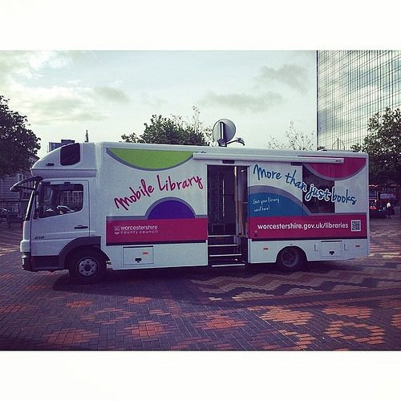
10:50 to 11:05 Lye Head, Little Lakes
11:15 to 11:30 Callow Hill, Forestry Cottages
11:35 to 11:45 Callow Hill, Abberley View
11:50 to 12:05 Rock, Badger Cottage
12:15 to 12:30 Rock, Timberdyne Close
12:40 to 12:55 Clows Top, Summit Road
13:00 to 13:20 Bayton, Church
13:25 to 13:40 Mamble, Sun & Slipper
14:25 to 14:40 Eardiston, The Garage

Additional Events & Locations where you can meet Act on Energy

Date Time Venue What

Thursday 21st 2.30pm -4.30pm The Entrance Foyer, Energy Advice drop
September Wyre Forest House, in session
Kidderminster, DY11 7WF

Thursday 28th 9.30am – 1.00pm Simply Limitless, Energy Advice drop
September Kidderminster, in session
DY11 5DF

If you are unable to attend our events please call our Freephone number 0800 988 2881 and speak to one of Act on Energy’s trained energy advisors who will assist with your enquiry.

Act on Energy working in partnership with Wyre Forest District Council
Tel: 0800 988 2881 www.actonenergy.org.uk advice@actonenergy.org.uk

